CHRISTMAS DAY

A SERVICE OF LESSONS & CAROLS
December 26, 2021 10:00 a.m.

PRELUDE

WELCOME AND MOMENT OF FELLOWSHIP

OPENING HYMN - "Oh Come, All Ye Faithful"

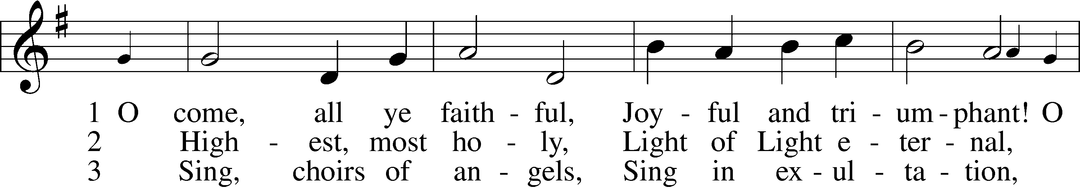
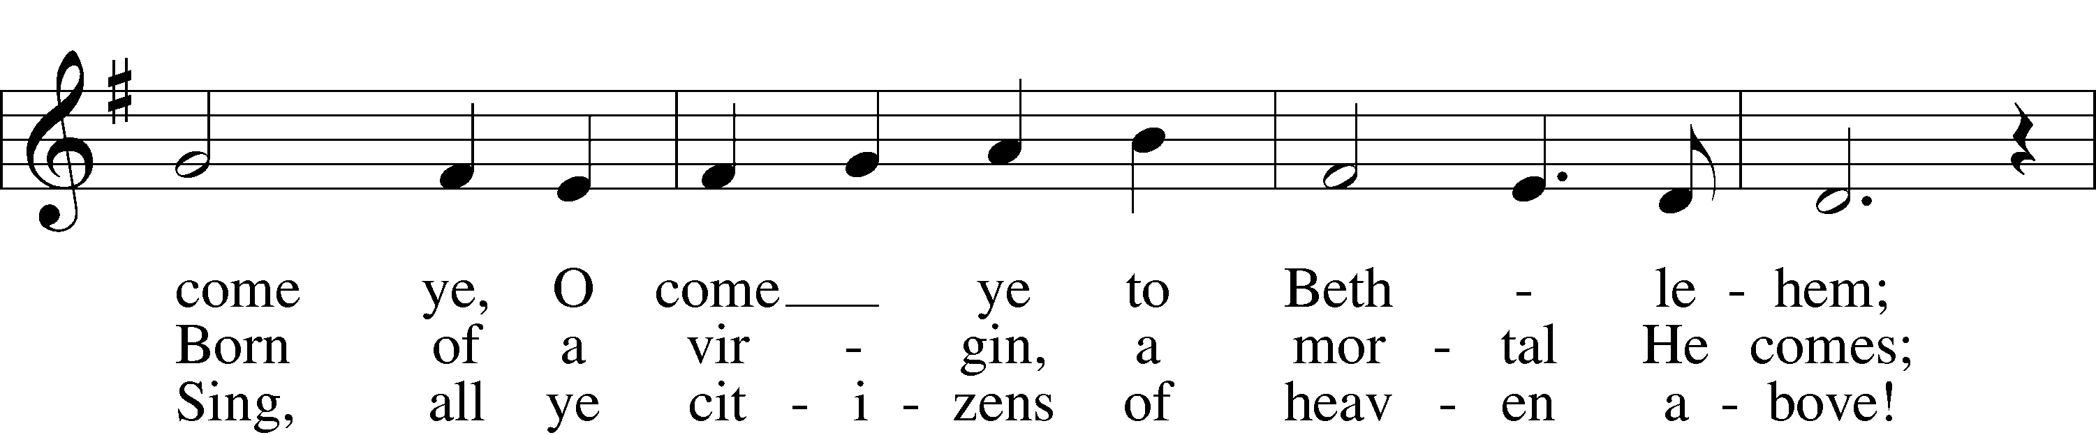
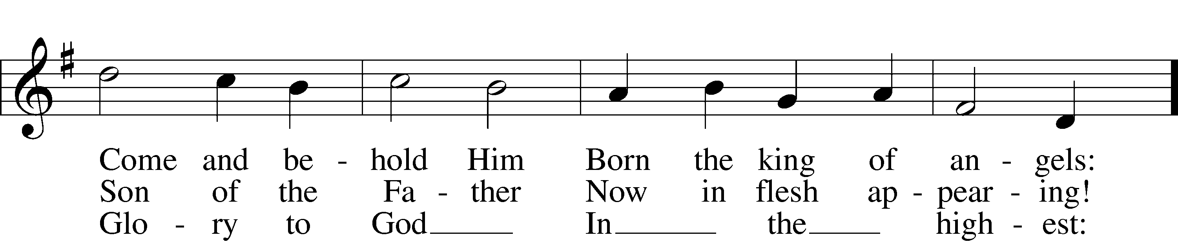
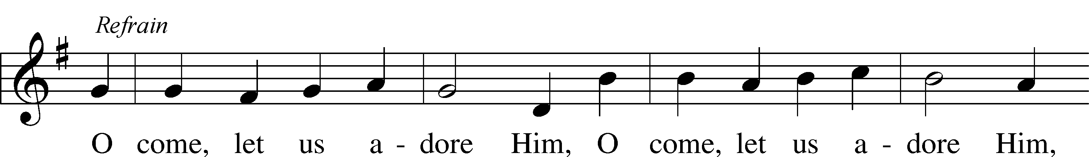
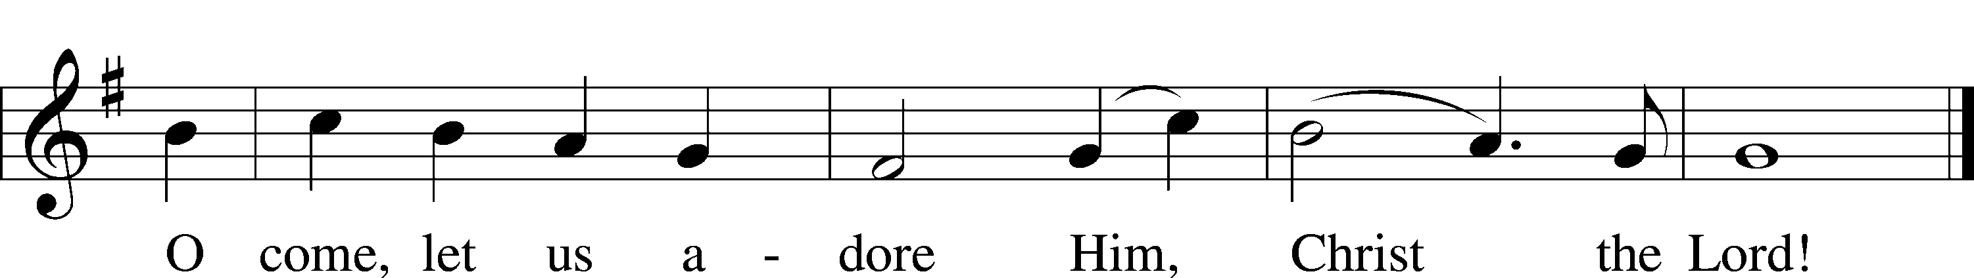
Text and tune: Public domain

INVOCATION
P The grace of our Lord Jesus Christ, the love of God and the communion of the Holy Spirit be with you all.
C And also with you

LIGHTING OF THE CHRISTMAS CANDLE

SCRIPTURE READING - Isaiah 7:14-16

¹⁴ Therefore the Lord himself will give you a sign: The virgin will conceive and give birth to a son, and will call him Immanuel. ¹⁵ He will be eating curds and honey when he knows enough to reject the wrong and choose the right, ¹⁶ for before the boy knows enough to reject the wrong and choose the right, the land of the two kings you dread will be laid waste.

HYMN- “What Child Is This”
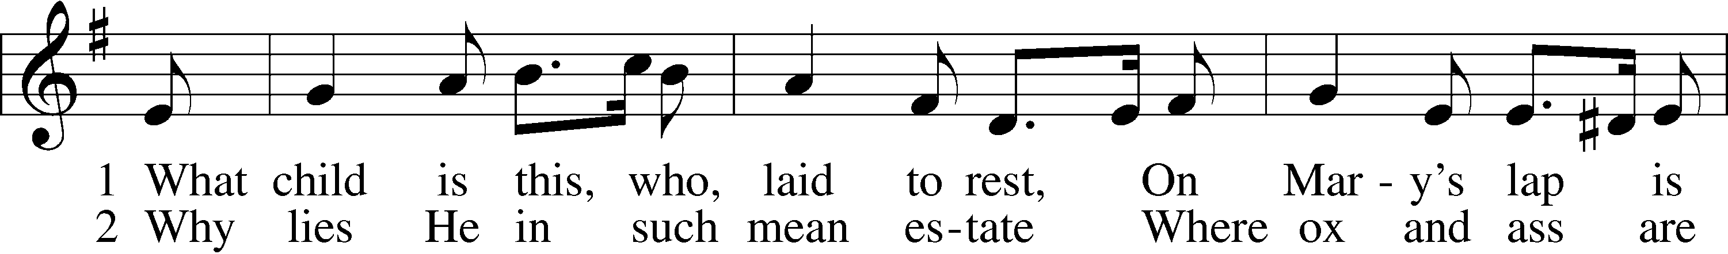
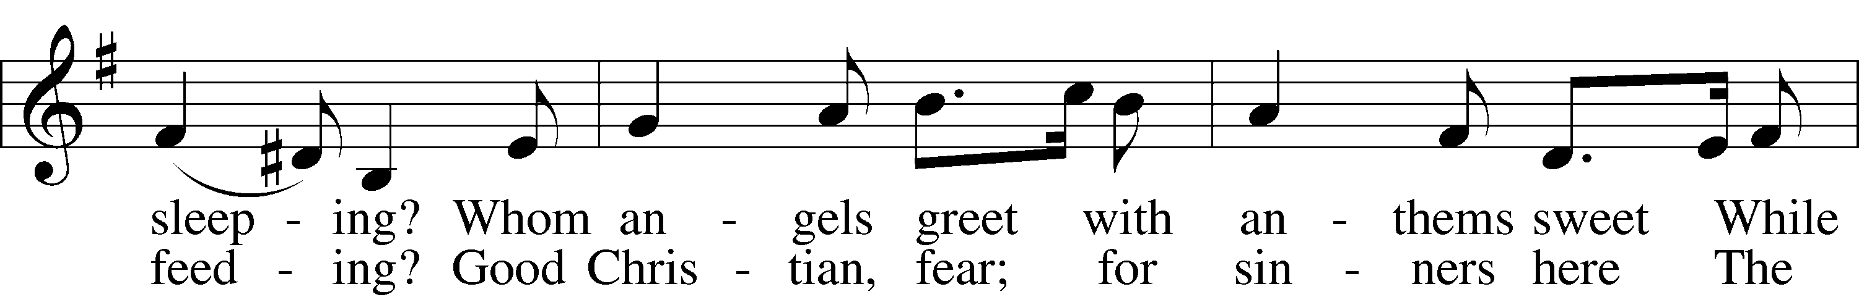
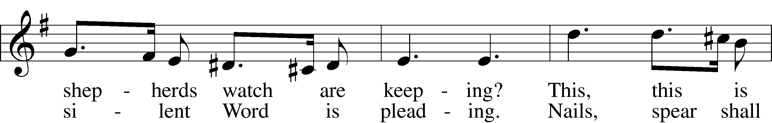
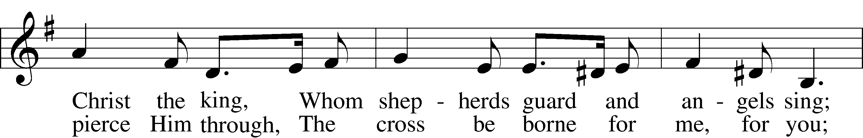
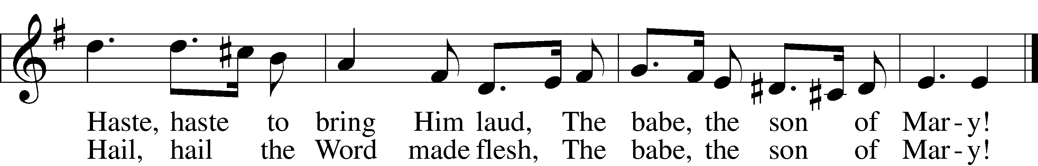
Text and tune: Public domain

SCRIPTURE READING – Isaiah 9:6

⁶ For to us a child is born,
to us a son is given,
and the government will be on his shoulders.
And he will be called
Wonderful Counselor, Mighty God,
Everlasting Father, Prince of Peace.

HYMN – “Angels From the Realms of Glory”
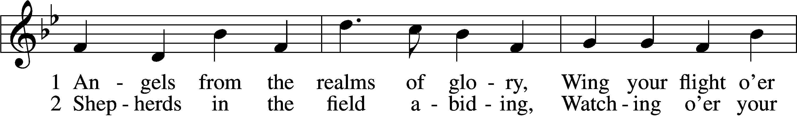
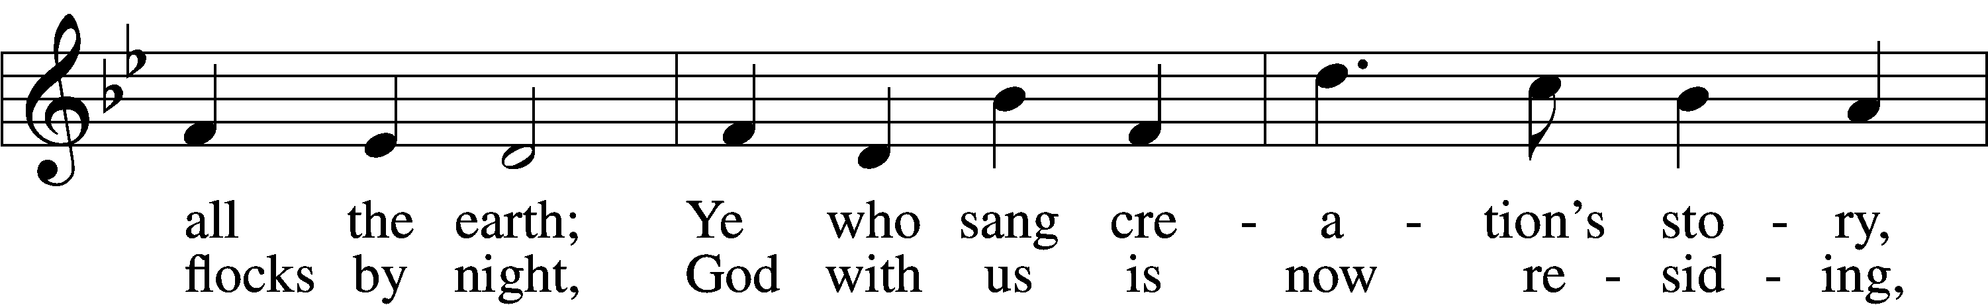
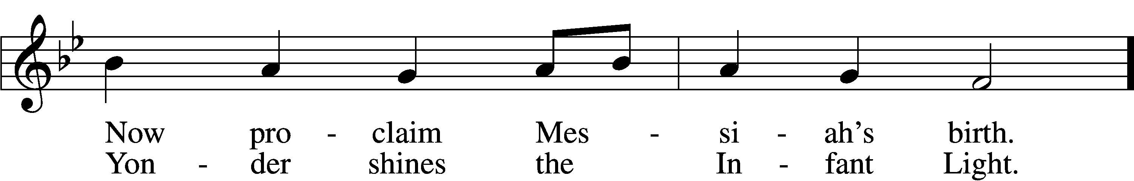
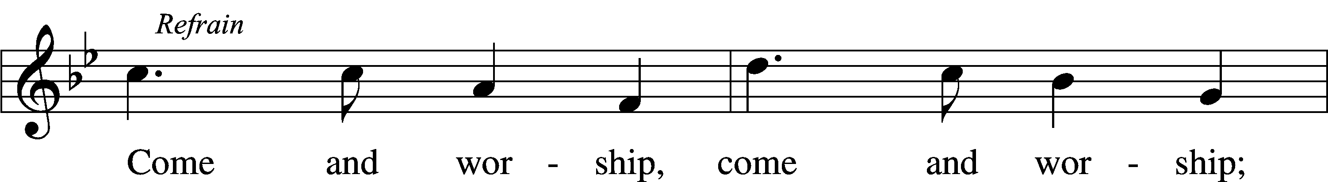
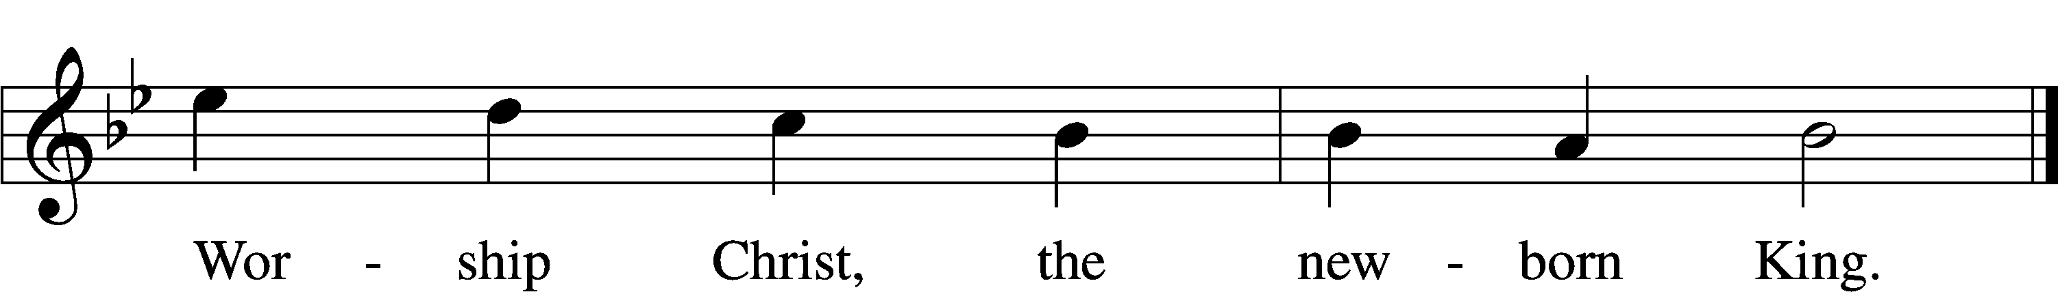
Text and tune: Public domain

SCRIPTURE READING - Isaiah 60:1-5
“Arise, shine, for your light has come,
and the glory of the Lord rises upon you.
² See, darkness covers the earth
and thick darkness is over the peoples,
but the Lord rises upon you
and his glory appears over you.
³ Nations will come to your light,
and kings to the brightness of your dawn.
⁴ “Lift up your eyes and look about you:
All assemble and come to you;
your sons come from afar,
and your daughters are carried on the hip.
⁵ Then you will look and be radiant,
your heart will throb and swell with joy;
the wealth on the seas will be brought to you,
to you the riches of the nations will come.

HYMN – “Arise and Shine in Splendor”

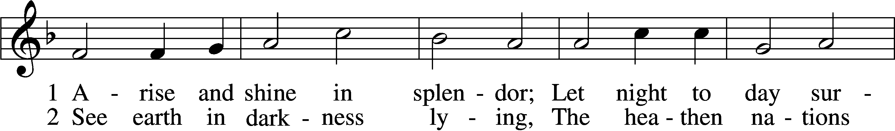
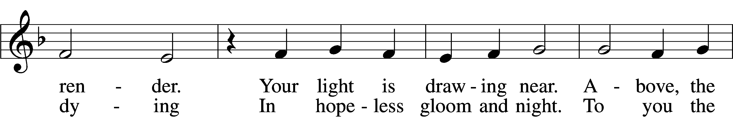
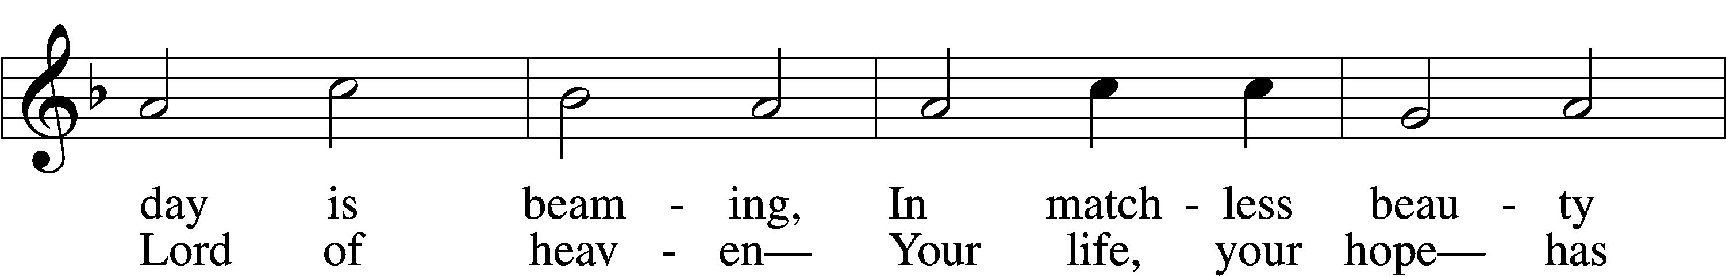
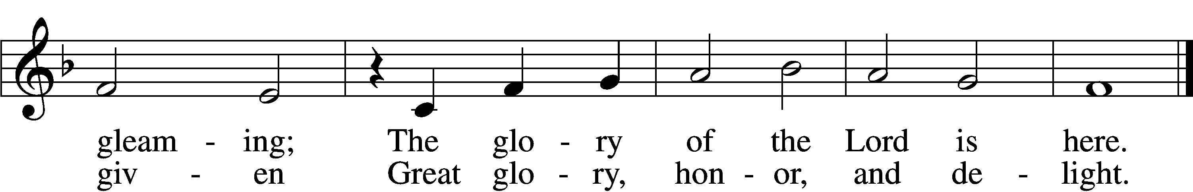
Tune: Public domain
Text: © 1941 Concordia Publishing House. Used by permission: LSB Hymn License no. 110000854

SCRIPTURE READING – Luke 2:1-7
In those days Caesar Augustus issued a decree that a census should be taken of the entire Roman world. ² (This was the first census that took place while Quirinius was governor of Syria.) ³ And everyone went to their own town to register.
⁴ So Joseph also went up from the town of Nazareth in Galilee to Judea, to Bethlehem the town of David, because he belonged to the house and line of David. ⁵ He went there to register with Mary, who was pledged to be married to him and was expecting a child. ⁶ While they were there, the time came for the baby to be born, ⁷ and she gave birth to her firstborn, a son. She wrapped him in cloths and placed him in a manger, because there was no guest room available for them.

HYMN – “The First Noël”

Verse 1

The First Noël, the angel did say
Was to certain poor shepherds in fields as they lay;
In fields as they lay, keeping their sheep,
On a cold winter’s night that was so deep.

Refrain:
Noël, Noël, Noël, Noël
Born is the King of Israel.

Verse 2
They looked up and saw a star
Shining in the east, beyond them far,
And to the earth it gave great light,
And so it continued both day and night
(Refrain)

SCRIPTURE READING – Luke 2:8-20
⁸ And there were shepherds living out in the fields nearby, keeping watch over their flocks at night. ⁹ An angel of the Lord appeared to them, and the glory of the Lord shone around them, and they were terrified. ¹⁰ But the angel said to them, “Do not be afraid. I bring you good news that will cause great joy for all the people. ¹¹ Today in the town of David a Savior has been born to you; he is the Messiah, the Lord. ¹² This will be a sign to you: You will find a baby wrapped in cloths and lying in a manger.”
¹³ Suddenly a great company of the heavenly host appeared with the angel, praising God and saying,
¹⁴ “Glory to God in the highest heaven,
and on earth peace to those on whom his favor rests.”
¹⁵ When the angels had left them and gone into heaven, the shepherds said to one another, “Let’s go to Bethlehem and see this thing that has happened, which the Lord has told us about.”
¹⁶ So they hurried off and found Mary and Joseph, and the baby, who was lying in the manger. ¹⁷ When they had seen him, they spread the word concerning what had been told them about this child, ¹⁸ and all who heard it were amazed at what the shepherds said to them. ¹⁹ But Mary treasured up all these things and pondered them in her heart. ²⁰ The shepherds returned, glorifying and praising God for all the things they had heard and seen, which were just as they had been told.

HYMN - “Angels We Have Heard on High”

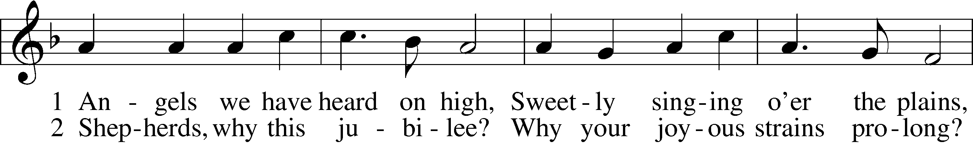
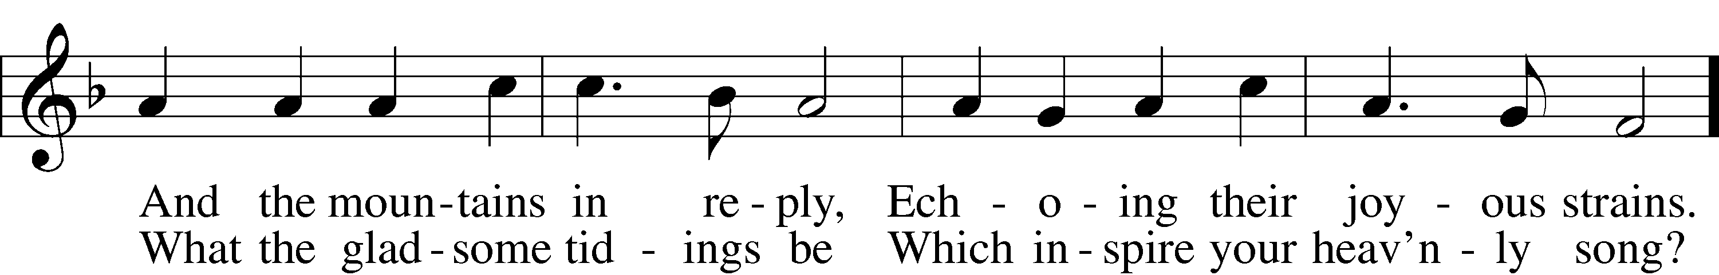
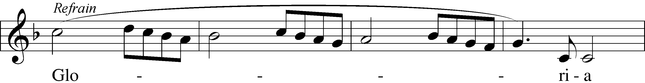
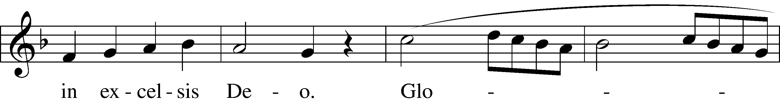
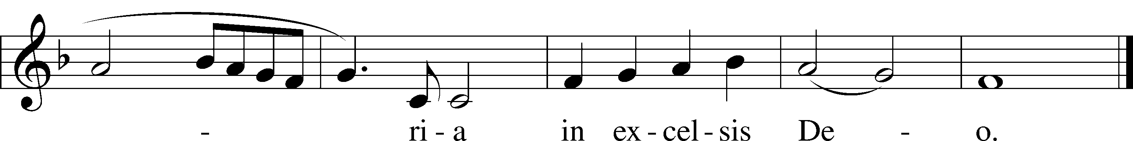
Text and tune: Public domain

SCRIPTURE READING – Matthew 2:1-12
After Jesus was born in Bethlehem in Judea, during the time of King Herod, Magi from the east came to Jerusalem ² and asked, “Where is the one who has been born king of the Jews? We saw his star when it rose and have come to worship him.”
³ When King Herod heard this he was disturbed, and all Jerusalem with him. ⁴ When he had called together all the people’s chief priests and teachers of the law, he asked them where the Messiah was to be born. ⁵ “In Bethlehem in Judea,” they replied, “for this is what the prophet has written:
⁶ “‘But you, Bethlehem, in the land of Judah,
are by no means least among the rulers of Judah;
for out of you will come a ruler who will shepherd my people Israel.’”
⁷ Then Herod called the Magi secretly and found out from them the exact time the star had appeared. ⁸ He sent them to Bethlehem and said, “Go and search carefully for the child. As soon as you find him, report to me, so that I too may go and worship him.”
⁹ After they had heard the king, they went on their way, and the star they had seen when it rose went ahead of them until it stopped over the place where the child was. ¹⁰ When they saw the star, they were overjoyed. ¹¹ On coming to the house, they saw the child with his mother Mary, and they bowed down and worshiped him. Then they opened their treasures and presented him with gifts of gold, frankincense and myrrh. ¹² And having been warned in a dream not to go back to Herod, they returned to their country by another route.

THE OFFERING

OFFERTORY

CONFESSION AND ABSOLUTION

P When the kindness and love of God our Savior appeared, He saved us, not because of righteous things we had done, but because of his mercy. We confess our unrighteousness, we plead for mercy.

C Comfort us, O Lord, for we are full of sin and there is no health in us. Daily we have sinned against You and against one another. Even as we try to save ourselves, we only end up alienating us further from You and from our brothers and sisters. We are sorry, Lord, and plead for Your comfort, for Your forgiveness, and for Your peace. Restore us to You, O Lord, and to one another, through the gift or Your Son, Jesus Christ, our Lord.

Silence for reflection and self examination
P Comfort, comfort my people says the voice of your God; speak with tenderness to Jerusalem and tell her that her struggle is ended and her sin has been pardoned. In the stead and by the command of my Lord and Savior Jesus Christ, I forgive you all your sins in the name of the Father, and of the Son and of the Holy Spirit.
People: Amen

WORDS OF INSTITUTION
P Our Lord Jesus Christ, on the night when He was betrayed, took bread, and when He had given thanks, He broke it and gave it to the disciples and said: “Take, eat; this is My body, which is given for you. This do in remembrance of Me.”
In the same way also He took the cup after supper, and when He had given thanks, He gave it to them, saying: “Drink of it, all of you; this cup is the new testament in My blood, which is shed for you for the forgiveness of sins. This do, as often as you drink it, in remembrance of Me.”

Pax Domini
P The peace of the Lord be with you always.
C And also with you.

THE LORD'S PRAYER
C Our Father who art in heaven,
hallowed be Thy name.
Thy kingdom come,
Thy will be done on earth as it is in heaven;
Give us this day our daily bread;
and forgive us our trespasses
as we forgive those who trespass against us;
and lead us not into temptation,
but deliver us from evil.
For Thine is the kingdom and the power and the
glory forever and ever. Amen.

COMMUNION DISTRIBUTION
Holy Cross believes that the Lord’s Supper is a gift of Jesus to His church. The apostle Paul wrote, “Let a man examine himself, and so eat of the bread and drink of the cup. For any one who eats and drinks without discerning the body eats and drinks judgment upon himself.” (I Corinthians 11:28-29). Out of loving concern for those that commune and from our understanding of the Bible and the Lutheran Confessions, we request that those who commune here:
1. Be baptized Christians
2. Should have received special instruction on the essence and
significance of the Lord’s Supper.
3. Are mature enough to examine themselves, recognizing their
sin and their need for God’s grace through this special
means.
4. Profess the “real presence” of Christ in this sacrament, that
is, confessing the true presence of Jesus’ body in the bread
and His blood in the wine.
We request that all that come to the Lord’s Supper join us in acknowledging the preceding affirmations of our understanding of communion. Non-communing children may join their parents. They are asked to fold their hands for a blessing. If you have any questions, please feel free to speak with the pastor after the service.

If you are unable to drink wine, the inner tray has alcohol free wine. If you are in need of gluten free bread, please speak with one of the pastors.

SINGING PRAYERS
P Today, O Lord we rejoice in your begotten son Jesus. We
sing in awe of your birth!

C (sung) “Away in a Manger”
Away in a manger, no crib for his bed,
The little Lord Jesus laid down his sweet head;
The stars in the sky looked down where he lay,
The little Lord Jesus asleep on the hay.
P Today, O Lord we praise you for saving us from sin. You
are the Messiah, our Savior.

C (sung) “O Little Town of Bethlehem”
O Holy Child of Bethlehem, Descend to us we pray;
Cast out our sin, and enter in, Be born in us today.
We hear the Christmas angels the great glad tidings tell;
O Come with us, abide with us, Our Lord Immanuel!

P Today, O Lord we laud your healing power and believe
you have authority over all created things.

C (sung) “Gentle Mary Laid Her Child”
Gentle Mary laid her child lowly in a manger;
There He lay, the Undefiled, to the world a stranger.
Such a babe in such a place, can He be the Savior?
Ask the saved of all the race who have found His favor.
P Today, O Lord, paradise comes to us. You gave us heaven.
We bless you.
C Amen!

PRAYERS OF THANKSGIVING
P Wondrous God: On this birthday of your Son, when we rehearse the Christmas stories we love so much, we confess with embarrassment that, if we had been around at the first Christmas, we might have missed it all! Some of us would have been too busy cleaning house to notice anything outside. Others would have been so engrossed in buying and selling, so engulfed in the hubbub of the marketplace, that we would not have noticed even the setting sun, let alone an odd little star that had no business being where it was. Even now, Father, we seldom pay real attention to signs and signals from you, missing messages of hope, comfort and love.
Help us to be more attentive, O God, to your presence: in a guiding star, in the angels’ song, in the small body of your newborn Son, but also in the face of a lonely, old woman or the sprawling shape of a homeless man. We pray in the name of the Holy Child who grew up to care and would have us care.
C Amen.

SCRIPTURE READING – Psalm 98
¹ Sing to the Lord a new song,
for he has done marvelous things;
his right hand and his holy arm
have worked salvation for him.
² The Lord has made his salvation known
and revealed his righteousness to the nations.
³ He has remembered his love
and his faithfulness to Israel;
all the ends of the earth have seen
the salvation of our God.
⁴ Shout for joy to the Lord, all the earth,
burst into jubilant song with music;
⁵ make music to the Lord with the harp,
with the harp and the sound of singing,
⁶ with trumpets and the blast of the ram’s horn—
shout for joy before the Lord, the King.
⁷ Let the sea resound, and everything in it,
the world, and all who live in it.
⁸ Let the rivers clap their hands,
let the mountains sing together for joy;
⁹ let them sing before the Lord,
for he comes to judge the earth.
He will judge the world in righteousness
and the peoples with equity.
RECESSIONAL HYMN – “Joy to the World”

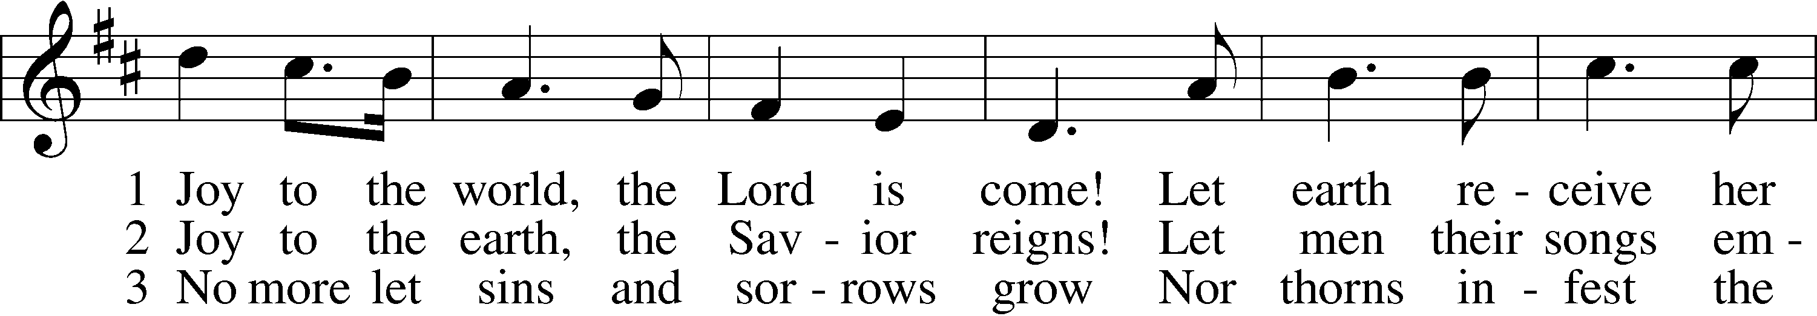
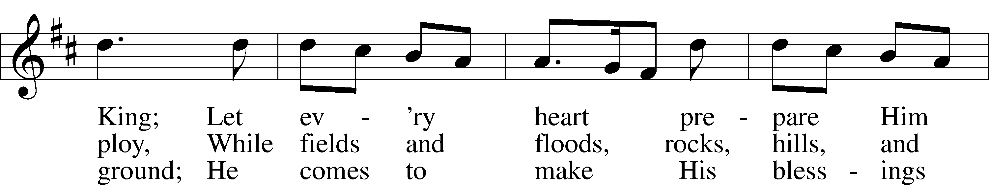
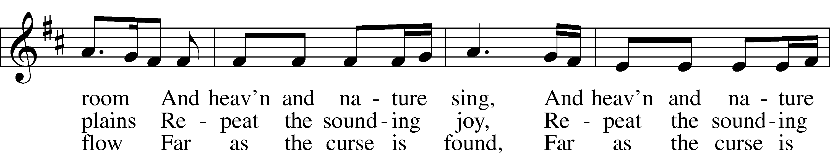
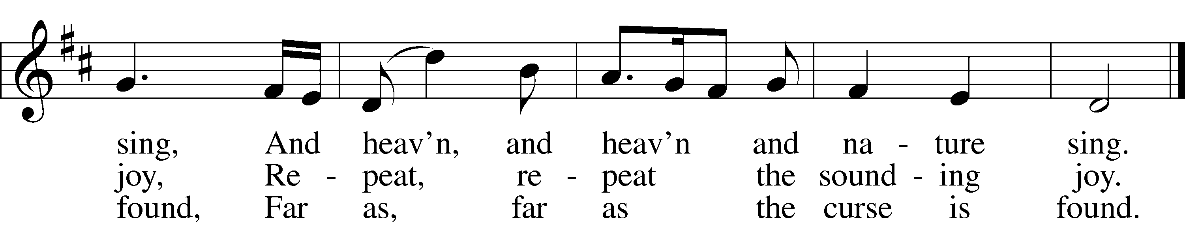
Text and tune: Public domain

Words of Departure
P Go in peace and serve the Lord!
C Thanks be to God!

POSTLUDE

