Newsletter July 31, 2022

Ecclesiastes 1: 2, 12-14, 2: 18-26 Colossians 3: 1-11 Luke 12: 13-21

Here are some ways to stay plugged in to HCLM:
Prepare for Sunday Services – worship song set lists, scripture readings, and questions for deeper thinking will be posted throughout the week on Facebook and Instagram
Praying for You – We have always believed in the power of prayer. If there is something weighing on your mind or want to submit a prayer, let us know through our prayer request form or email prayer@hclm.org.
Online or In Person Services – Sunday at 8:00 a.m. for traditional service or 10:00 a.m. for contemporary
Holy Cross Lake Mary Podcast – Check out and subscribe to our new podcast on iTunes or Spotify. You can also simply ask Alexa to “play the Holy Cross Lake Mary Podcast”

TITHES & OFFERINGS
We give because we recognize that God has blessed us immensely and so we honor Him by giving back to Him out of our tithes and offerings. You can give online at hclm.org/give or mail to church address at 780 N Sun Drive, Lake Mary, FL 32746.

UPCOMING EVENTS AND ACTIVITIES

Divine Dollies: The “Divine Dollies” will gather for lunch on Tuesday, August 2nd, 11:30 a.m., at Carrabba’s Italian Grill, 4675 St. Johns Parkway, Sanford. Please RSVP to Ella Bieber by 8-1 at 407-383-6471, dannynella@gmail.com.

HCLA Teacher Commissioning: Please join us to pray for all of our academy teachers and students on Sunday August 7th at the 10 am service for a great school year.
The Third Tuesday Lunch Bunch: is scheduled to meet/greet/eat on August 16th, 11:30 a.m., at Filomena’s Pizzeria & Ristorante, 3590 N. US 17-92, Lake Mary. Please let Gayle Curtis know by 8-15 if you’ll be joining the group, lovellg2@aol.com, 407-314-5388.

Baby Shower: Our very own Blake and Emily are having a baby! Please plan on helping us celebrate their new bundle of joy on September 11th at 11:30 am in the community center. The baby girl will be arriving in December! Blake and Emily are registered at Amazon.

LWM – Mite box collection – The 4th Sunday of every month is Mite Sunday. The Mission grants are behind by thousands of dollars for the FL-GA district. Please remember to start filling your boxes! The LWM mites collected each month benefit many wonderful mission projects. Here is a link to some current projects through the FL-GA LWM District Mission Grants (over $126,000!!!). https://flgalwml.com/mission_grants_disbursed Please remember to keep collecting your mites. If you need additional mite boxes, etc., please contact Christine Jennison.

Let’s Serve! – With the help of the city of Lake Mary we have identified someone that needs our help. It’s going to require about two days of yard work, cleaning out a very overgrown yard. If you can help, please let us know your availability. It’s possible we may be able to schedule something both on a weekend as well as during the week. Please contact Pastor Matt if you are able to help and we will start the scheduling process.
00:00
St. Luke’s Concert Series – Fall season kicks off with the Brass Band Of Central Florida Concert, Friday, September 9th at 7pm.

YOUTH & CHILDREN’S MINISTRY
Kids Church!!! – Is taking a summer break and will return next week August 7th at 10 am with a pancake breakfast kick off!
Kids K-5 Join Children’s Director Emily at 10 am in the Children’s Center! Great News, the kid’s church is growing, and Emily could use your help when it returns on August 7th. Contact ewright@thehcla.org if you can help.

Youth Ministry
Join Youth Director Blake during the 9 am Education Hour at the Mean Bean Coffee Shop
The Youth Group will return to Wednesday nights with Blake on August 10th to kick off the school year (6pm – 8pm)!

L-TEAM NEWS AND CALENDAR*

Sunday
Adult Bible Study 9 a.m.
Student Ministry 9 a.m.
Kid’s Church 10 a.m. – upstairs in the Children’s Center with Emily (On summer break, will return August 7th with a pancake breakfast!)

Monday
Men’s Bible Study 7 a.m. (Pastor Chris)
Men’s Ministry 7:30 p.m.
Ladies Book Club (4th Monday only) 7 p.m.

Wednesday
Wednesday Morning Bible Study 10:30 a.m.
Worship Team Practice 6:45 p.m.

Thursday
Ladies Bible Study by LWM will meet in the coffee shop “The Mean Bean” at HCLM every Thursday at 6:30pm. For more information Sharon Shyrock (ssshyrock@yahoo.com).

Next Week & Beyond
*If you are interested in starting an L-Team or your existing L-Team has resumed, please email Pastor Matt or Pastor Chris.

VOLUNTEER SPOTLIGHT: YOUTH GROUP MISSION TRIP
The
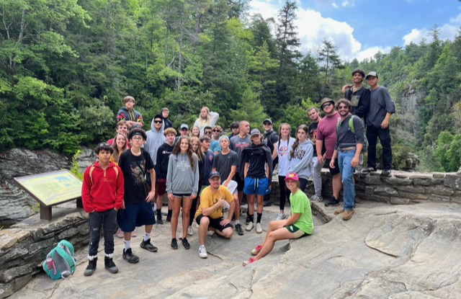00:00
01:16
Holy Cross has always had a faithful group of servants helping during the 8 am and 10 am service. We need more! Please see Pastor Matt or email him at mwallis@hclm.org if you can help with ushering or as a communion assistant.
There are some exciting things happening at youth group, and one of the most exciting things is that our youth group is growing! With growth, we need small group adult leaders for both middle school and high school students. Being a small group leader is an incredible way to get involved in our church community as well as getting to know students who are the future of the Church! If you or somebody you know may be interested in being a part of what happens at Holy Cross on Wednesday nights, please let Blake know at bwright@thehcla.org!

ANNOUNCEMENTS & UPDATES

Let’s Bake!
Come check out all the free cookie cutters of various shapes and holidays, as well as other miscellaneous items (including the containers). Any items left over will be donated after Sunday July 31st.
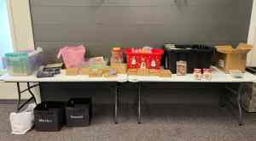

Job openings at Holy Cross Lutheran Academy
Accepting resumes for the 2022-2023 School Year for Substitute Teachers. (Holy Cross Lutheran Academy offers employment opportunities to qualified individuals who desire to serve Christ as well as the students, families, and staff of HCLA.) For more information go to https://thehcla.org/careers/

Metal Collection Notes:
Aluminum cans and any other non-serviceable metals can be recycled. Two collection points are available: the blue box in the courtyard and the other is behind the dumpster inside the enclosure. All aluminum cans and any metal objects no longer serviceable are gladly accepted.
All donations are greatly appreciated for this worthy cause. Thank you! Contact Warren Jennison @321-377-8524 with any questions/comments about the ministry. All profits go to the youth.

The Sharing Center:
We know all of you are so generous donating your gently used items to the Sharing Center. HCLM is only collecting food items for the Sharing Center at this time. Please bring your clothing and household donations directly to the Sharing Center.

Have something you want in the weekly?
Please let the office know by Noon Thursday so it can get published for the weekend.

Communion:
Communion is available in our in-person services (1st and 3rd Sunday at 8am and 2nd & 4th Sunday at 10am). For those who are not able to get to a service or are not yet comfortable attending in person services, please contact the office or one of the pastors and we will be happy to make other arrangements.

PRAYERS OF THE CHURCH

Prayers of Thanksgiving
Kristie Pepper – Thankful she made it safely to Detroit and started her new job this past week.
Prayers of Healing
Jim Lillo – Jim has surgery on August 2nd to remove a tumor and blood clot from his bladder. Please pray for a quick recovery.
Carolyn Litwin – Carolyn also has surgery on August 2nd. Please pray for a quick recovery for her as well.
*Pray for all those suffering from coronavirus
General Prayers
Doug Jones – Doug is in the Air Force boot camp. Please pray for his achievements & safety and for his wife (Chelsea) and child (Kai).
We pray today for our nation and our world. We ask that God would be with all our leaders and elected officials; we pray that He would bring peace to the world, an end to violence and especially watch over Christians that are facing persecution.

Prayers for Healing from Cancer
Bruce Asher Rick Lembrich
Laken Binkley Lori Luedtke
Gary Brown Charaline Luna
Becky Burrell Jean Mactye
Austin Chen Rick Mann
Kyle Corbett Kathy Morgan
Deb Fadool John Myron
Tosha Feldman Bradford Plog
Michael Francis Ivis Rodriquez
Pat Goodwine Wayne Scheussler
Jerry Gross Karen Schlue
Todd Haynes Debbie Shaffer
Jerry Hoffman Gina Shaffer
Marlin Houser Walt Shields
Alan Kimball Sue Stark
Elizabeth Koob Scott Williams

“Casting a light to help those who are lost find their way in Christ”

Sunday Services at 8:00 a.m., and 10:00 a.m. in the Worship Center

and Online on Facebook and YouTube.com/hclm

Senior Pastor Matt Wallis (mwallis@hclm.org)
Family Life Pastor Chris Johnson (chrisj@hclm.org)

www.hclm.org Facebook: facebook.com/lakemarychurch

